SQL
- SQL stands for Structured Query Language. It is used for storing and managing data in relational database management system (RDMS).
- It is a standard language for Relational Database System. It enables a user to create, read, update and delete relational databases and tables.
- All the RDBMS like MySQL, Informix, Oracle, MS Access and SQL Server use SQL as their standard database language.
- SQL allows users to query the database in a number of ways, using English-like statements.

Rules:
SQL follows the following rules:
- Structure query language is not case sensitive. Generally, keywords of SQL are written in uppercase.
- Statements of SQL are dependent on text lines. We can use a single SQL statement on one or multiple text line.
- Using the SQL statements, you can perform most of the actions in a database.
- SQL depends on tuple relational calculus and relational algebra.

SQL process:
- When an SQL command is executing for any RDBMS, then the system figure out the best way to carry out the request and the SQL engine determines that how to interpret the task.
- In the process, various components are included. These components can be optimization Engine, Query engine, Query dispatcher, classic, etc.
- All the non-SQL queries are handled by the classic query engine, but SQL query engine won't handle logical files.
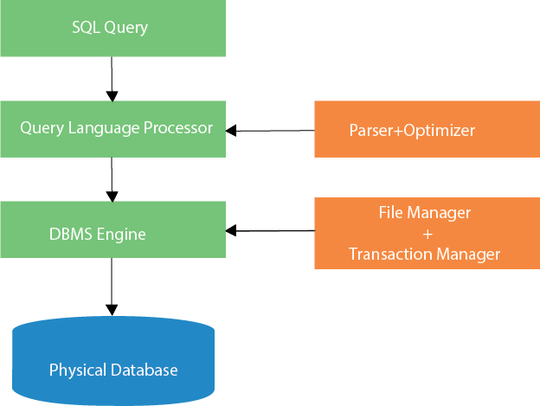

Characteristics of SQL
- SQL is easy to learn.
- SQL is used to access data from relational database management systems.
- SQL can execute queries against the database.
- SQL is used to describe the data.
- SQL is used to define the data in the database and manipulate it when needed.
- SQL is used to create and drop the database and table.
- SQL is used to create a view, stored procedure, function in a database.
- SQL allows users to set permissions on tables, procedures, and views.

Advantages of SQL
There are the following advantages of SQL:

High speed
Using the SQL queries, the user can quickly and efficiently retrieve a large amount of records from a database.

No coding needed
In the standard SQL, it is very easy to manage the database system. It doesn't require a substantial amount of code to manage the database system.

Well defined standards
Long established are used by the SQL databases that are being used by ISO and ANSI.

Portability
SQL can be used in laptop, PCs, server and even some mobile phones.

Interactive language
SQL is a domain language used to communicate with the database. It is also used to receive answers to the complex questions in seconds.

Multiple data view
Using the SQL language, the users can make different views of the database structure.

SQL Commands
- SQL commands are instructions. It is used to communicate with the database. It is also used to perform specific tasks, functions, and queries of data.
- SQL can perform various tasks like create a table, add data to tables, drop the table, modify the table, set permission for users.

Types of SQL Commands
There are five types of SQL commands: DDL, DML, DCL, TCL, and DQL.
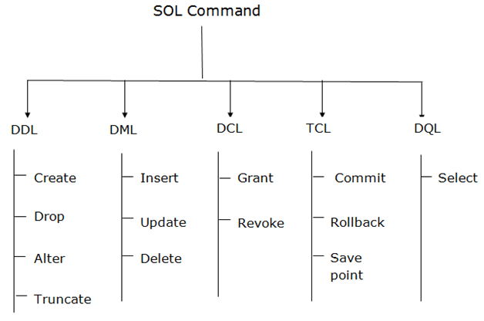

1. Data Definition Language (DDL)
- DDL changes the structure of the table like creating a table, deleting a table, altering a table, etc.
- All the command of DDL are auto-committed that means it permanently save all the changes in the database.
Here are some commands that come under DDL:
- CREATE
- ALTER
- DROP
- TRUNCATE
a. CREATE It is used to create a new table in the database.
Syntax:
CREATE TABLE TABLE_NAME (COLUMN_NAME DATATYPES[,....]);
b. DROP: It is used to delete both the structure and record stored in the table.
Syntax
- DROP TABLE table_name;
Example
DROP TABLE EMPLOYEE;
c. ALTER: It is used to alter the structure of the database. This change could be either to modify the characteristics of an existing attribute or probably to add a new attribute.
Syntax:
To add a new column in the table
ALTER TABLE table_name ADD column_name COLUMN-definition;
To modify existing column in the table:
ALTER TABLE table_name MODIFY(column_definitions....);
EXAMPLE
ALTER TABLE STU_DETAILS ADD(ADDRESS VARCHAR2(20));
ALTER TABLE STU_DETAILS MODIFY (NAME VARCHAR2(20));
d. TRUNCATE: It is used to delete all the rows from the table and free the space containing the table.
Syntax:
TRUNCATE TABLE table_name;
Example:
TRUNCATE TABLE EMPLOYEE;

2. Data Manipulation Language
- DML commands are used to modify the database. It is responsible for all form of changes in the database.
- The command of DML is not auto-committed that means it can't permanently save all the changes in the database. They can be rollback.
Here are some commands that come under DML:
- INSERT
- UPDATE
- DELETE
a. INSERT: The INSERT statement is a SQL query. It is used to insert data into the row of a table.
Syntax:
INSERT INTO TABLE_NAME
(col1, col2, col3,.... col N)
VALUES (value1, value2, value3, .... valueN);
Or
INSERT INTO TABLE_NAME
VALUES (value1, value2, value3, .... valueN);
For example:
INSERT INTO javatpoint (Author, Subject) VALUES ("Sonoo", "DBMS");
b. UPDATE: This command is used to update or modify the value of a column in the table.
Syntax:
UPDATE table_name SET [column_name1= value1,...column_nameN = valueN] [WHERE CONDITION]
For example:
UPDATE students
SET User_Name = 'Sonoo'
WHERE Student_Id = '3'
c. DELETE: It is used to remove one or more row from a table.
Syntax:
DELETE FROM table_name [WHERE condition];
For example:
DELETE FROM javatpoint
WHERE Author="Sonoo";

3. Data Control Language
DCL commands are used to grant and take back authority from any database user.
Here are some commands that come under DCL:
- Grant
- Revoke

a. Grant: It is used to give user access privileges to a database.
Example
GRANT SELECT, UPDATE ON MY_TABLE TO SOME_USER, ANOTHER_USER;
b. Revoke: It is used to take back permissions from the user.
Example
REVOKE SELECT, UPDATE ON MY_TABLE FROM USER1, USER2;

4. Transaction Control Language
TCL commands can only use with DML commands like INSERT, DELETE and UPDATE only.
These operations are automatically committed in the database that's why they cannot be used while creating tables or dropping them.
Here are some commands that come under TCL:
- COMMIT
- ROLLBACK
- SAVEPOINT
a. Commit: Commit command is used to save all the transactions to the database.
Syntax:
COMMIT;
Example:
DELETE FROM CUSTOMERS
WHERE AGE = 25;
COMMIT;

b. Rollback: Rollback command is used to undo transactions that have not already been saved to the database.
Syntax:
ROLLBACK;
Example:
DELETE FROM CUSTOMERS
WHERE AGE = 25;
ROLLBACK;
c. SAVEPOINT: It is used to roll the transaction back to a certain point without rolling back the entire transaction.
Syntax:
SAVEPOINT SAVEPOINT_NAME;

ROLLBACK TO SAVEPOINT_NAME;

5. Data Query Language
DQL is used to fetch the data from the database.
It uses only one command:
- SELECT
a. SELECT: This is the same as the projection operation of relational algebra. It is used to select the attribute based on the condition described by WHERE clause.
Syntax:
SELECT expressions
FROM TABLES
WHERE conditions;
For example:
SELECT emp_name
FROM employee
WHERE age > 20;

SQL Operator
There are various types of SQL operator:
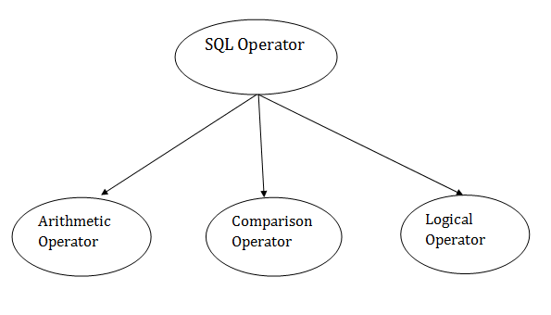

SQL Arithmetic Operators
Let's assume 'variable a' and 'variable b'. Here, 'a' contains 20 and 'b' contains 10.
Operator | Description | Example
+ | It adds the value of both operands. | a+b will give 30
- | It is used to subtract the right-hand operand from the left-hand operand. | a-b will give 10
* | It is used to multiply the value of both operands. | a*b will give 200
/ | It is used to divide the left-hand operand by the right-hand operand. | a/b will give 2
% | It is used to divide the left-hand operand by the right-hand operand and returns reminder. | a%b will give 0

SQL Comparison Operators:
Let's assume 'variable a' and 'variable b'. Here, 'a' contains 20 and 'b' contains 10.
Operator | Description | Example
= | It checks if two operands values are equal or not, if the values are queal then condition becomes true. | (a=b) is not true
!= | It checks if two operands values are equal or not, if values are not equal, then condition becomes true. | (a!=b) is true
<> | It checks if two operands values are equal or not, if values are not equal then condition becomes true. | (a<>b) is true
> | It checks if the left operand value is greater than right operand value, if yes then condition becomes true. | (a>b) is not true
< | It checks if the left operand value is less than right operand value, if yes then condition becomes true. | (a<b) is true
>= | It checks if the left operand value is greater than or equal to the right operand value, if yes then condition becomes true. | (a>=b) is not true
<= | It checks if the left operand value is less than or equal to the right operand value, if yes then condition becomes true. | (a<=b) is true
!< | It checks if the left operand value is not less than the right operand value, if yes then condition becomes true. | (a!=b) is not true
!> | It checks if the left operand value is not greater than the right operand value, if yes then condition becomes true. | (a!>b) is true

SQL Logical Operators
There is the list of logical operator used in SQL:

Operator | Description
ALL | It compares a value to all values in another value set.
AND | It allows the existence of multiple conditions in an SQL statement.
ANY | It compares the values in the list according to the condition.
BETWEEN | It is used to search for values that are within a set of values.
IN | It compares a value to that specified list value.
NOT | It reverses the meaning of any logical operator.
OR | It combines multiple conditions in SQL statements.
EXISTS | It is used to search for the presence of a row in a specified table.
LIKE | It compares a value to similar values using wildcard operator.

SQL Table
- SQL Table is a collection of data which is organized in terms of rows and columns. In DBMS, the table is known as relation and row as a tuple.
- Table is a simple form of data storage. A table is also considered as a convenient representation of relations.

Let's see an example of the EMPLOYEE table:
EMP_ID | EMP_NAME | CITY | PHONE_NO
1 | Kristen | Washington | 7289201223
2 | Anna | Franklin | 9378282882
3 | Jackson | Bristol | 9264783838
4 | Kellan | California | 7254728346
5 | Ashley | Hawaii | 9638482678

In the above table, "EMPLOYEE" is the table name, "EMP_ID", "EMP_NAME", "CITY", "PHONE_NO" are the column names. The combination of data of multiple columns forms a row, e.g., 1, "Kristen", "Washington" and 7289201223 are the data of one row.

Operation on Table
- Create table
- Drop table
- Delete table
- Rename table

SQL Create Table
SQL create table is used to create a table in the database. To define the table, you should define the name of the table and also define its columns and column's data type.
Syntax
create table "table_name"
("column1" "data type",
"column2" "data type",
"column3" "data type",
...
"columnN" "data type");
Example
SQL> CREATE TABLE EMPLOYEE (
EMP_ID INT NOT NULL,
EMP_NAME VARCHAR (25) NOT NULL,
PHONE_NO INT NOT NULL,
ADDRESS CHAR (30),
PRIMARY KEY (ID)
);
If you create the table successfully, you can verify the table by looking at the message by the SQL server. Else you can use DESC command as follows:
SQL> DESC EMPLOYEE;
Field | Type | Null | Key | Default | Extra
EMP_ID | int(11) | NO | PRI | NULL
EMP_NAME | varchar(25) | NO |  | NULL
PHONE_NO | NO | int(11) |  | NULL
ADDRESS | YES |  |  | NULL | char(30)

- 4 rows in set (0.35 sec)
Now you have an EMPLOYEE table in the database, and you can use the stored information related to the employees.

Drop table
A SQL drop table is used to delete a table definition and all the data from a table. When this command is executed, all the information available in the table is lost forever, so you have to very careful while using this command.
Syntax
DROP TABLE "table_name";
Firstly, you need to verify the EMPLOYEE table using the following command:
SQL> DESC EMPLOYEE;
Field | Type | Null | Key | Default | Extra
EMP_ID | int(11) | NO | PRI | NULL
EMP_NAME | varchar(25) | NO |  | NULL
PHONE_NO | NO | int(11) |  | NULL
ADDRESS | YES |  |  | NULL | char(30)

- 4 rows in set (0.35 sec)
This table shows that EMPLOYEE table is available in the database, so we can drop it as follows:
SQL>DROP TABLE EMPLOYEE;
Now, we can check whether the table exists or not using the following command:
Query OK, 0 rows affected (0.01 sec)
As this shows that the table is dropped, so it doesn't display it.

SQL DELETE table
In SQL, DELETE statement is used to delete rows from a table. We can use WHERE condition to delete a specific row from a table. If you want to delete all the records from the table, then you don't need to use the WHERE clause.
Syntax
DELETE FROM table_name WHERE condition;

Example
Suppose, the EMPLOYEE table having the following records:
EMP_ID | EMP_NAME | CITY | PHONE_NO | SALARY
1 | Kristen | Chicago | 9737287378 | 150000
2 | Russell | Austin | 9262738271 | 200000
3 | Denzel | Boston | 7353662627 | 100000
4 | Angelina | Denver | 9232673822 | 600000
5 | Robert | Washington | 9367238263 | 350000
6 | Christian | Los angels | 7253847382 | 260000
The following query will DELETE an employee whose ID is 2.
SQL> DELETE FROM EMPLOYEE
WHERE EMP_ID = 3;
Now, the EMPLOYEE table would have the following records.
EMP_ID | EMP_NAME | CITY | PHONE_NO | SALARY
1 | Kristen | Chicago | 9737287378 | 150000
2 | Russell | Austin | 9262738271 | 200000
4 | Angelina | Denver | 9232673822 | 600000
5 | Robert | Washington | 9367238263 | 350000
6 | Christian | Los angels | 7253847382 | 260000

If you don't specify the WHERE condition, it will remove all the rows from the table.
DELETE FROM EMPLOYEE;
Now, the EMPLOYEE table would not have any records.

SQL Aggregate Functions
- SQL aggregation function is used to perform the calculations on multiple rows of a single column of a table. It returns a single value.
- It is also used to summarize the data.

Types of SQL Aggregation Function
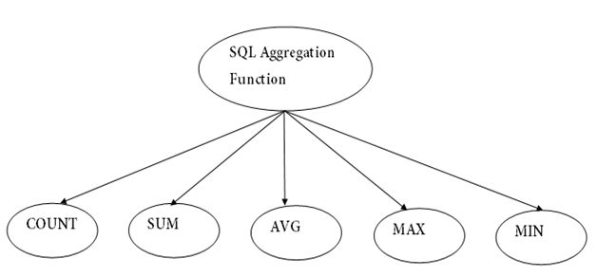

1.COUNT FUNCTION
- COUNT function is used to Count the number of rows in a database table. It can work on both numeric and non-numeric data types.
- COUNT function uses the COUNT(*) that returns the count of all the rows in a specified table. COUNT(*) considers duplicate and Null.
Syntax
COUNT(*)
or
COUNT( [ALL|DISTINCT] expression )

Sample table:
PRODUCT_MAST
PRODUCT | COMPANY | QTY | RATE | COST
Item1 | Com1 | 2 | 10 | 20
Item2 | Com2 | 3 | 25 | 75
Item3 | Com1 | 2 | 30 | 60
Item4 | Com3 | 5 | 10 | 50
Item5 | Com2 | 2 | 20 | 40
Item6 | Cpm1 | 3 | 25 | 75
Item7 | Com1 | 5 | 30 | 150
Item8 | Com1 | 3 | 10 | 30
Item9 | Com2 | 2 | 25 | 50
Item10 | Com3 | 4 | 30 | 120
Example: COUNT()
SELECT COUNT(*)
FROM PRODUCT_MAST;
Output:
10
Example: COUNT with WHERE
SELECT COUNT(*)
FROM PRODUCT_MAST;
WHERE RATE>=20;
Output:
7
Example: COUNT() with DISTINCT
SELECT COUNT(DISTINCT COMPANY)
FROM PRODUCT_MAST;
Output:
3
Example: COUNT() with GROUP BY
SELECT COMPANY, COUNT(*)
FROM PRODUCT_MAST
GROUP BY COMPANY;
Output:
Column1 5
Com1 5
Com2 3
Com3 2

Example: COUNT() with HAVING
SELECT COMPANY, COUNT(*)
FROM PRODUCT_MAST
GROUP BY COMPANY
HAVING COUNT(*)>2;
Output:
Com1 5
Com2 3

2. SUM Function
Sum function is used to calculate the sum of all selected columns. It works on numeric fields only.

Syntax
SUM()
or
SUM( [ALL|DISTINCT] expression )
Example: SUM()
SELECT SUM(COST)
FROM PRODUCT_MAST;
Output:
670
Example: SUM() with WHERE
SELECT SUM(COST)
FROM PRODUCT_MAST
WHERE QTY>3;
Output:
320

Example: SUM() with GROUP BY
SELECT SUM(COST)
FROM PRODUCT_MAST
WHERE QTY>3
GROUP BY COMPANY;
Output:
Com1 150
Com2 170

Example: SUM() with HAVING
SELECT COMPANY, SUM(COST)
FROM PRODUCT_MAST
GROUP BY COMPANY
HAVING SUM(COST)>=170;
Output:
Com1 335
Com2 170

3. AVG function
The AVG function is used to calculate the average value of the numeric type. AVG function returns the average of all non-Null values.
Syntax
AVG()
or
AVG( [ALL|DISTINCT] expression )
Example:
SELECT AVG(COST)
FROM PRODUCT_MAST;

Output:
67.0

4. MAX Function
MAX function is used to find the maximum value of a certain column. This function determines the largest value of all selected values of a column.
Syntax
MAX()
or
MAX( [ALL|DISTINCT] expression )
Example:
SELECT MAX(RATE)
FROM PRODUCT_MAST;
Output
30

5. MIN Function
MIN function is used to find the minimum value of a certain column. This function determines the smallest value of all selected values of a column.
Syntax
MIN()
or
MIN( [ALL|DISTINCT] expression )
Example:
SELECT MIN(RATE)
FROM PRODUCT_MAST;
Output:
10

SQL INSERT Statement
The SQL INSERT statement is used to insert a single or multiple data in a table. In SQL, You can insert the data in two ways:
- Without specifying column name
- By specifying column name

Sample Table
EMPLOYEE
EMP_ID | EMP_NAME | CITY | SALARY | AGE
1 | Angelina | Chicago | 200000 | 30
2 | Robert | Austin | 300000 | 26
3 | Christian | Denver | 100000 | 42
4 | Kristen | Washington | 500000 | 29
5 | Russell | Los angels | 200000 | 36

1. Without specifying column name
If you want to specify all column values, you can specify or ignore the column values.
Syntax
INSERT INTO TABLE_NAME
VALUES (value1, value2, value 3, .... Value N);
Query
INSERT INTO EMPLOYEE VALUES (6, 'Marry', 'Canada', 600000, 48);
Output: After executing this query, the EMPLOYEE table will look like:
EMP_ID | EMP_NAME | CITY | SALARY | AGE
1 | Angelina | Chicago | 200000 | 30
2 | Robert | Austin | 300000 | 26
3 | Christian | Denver | 100000 | 42
4 | Kristen | Washington | 500000 | 29
5 | Russell | Los angels | 200000 | 36
6 | Marry | Canada | 600000 | 48

2. By specifying column name
To insert partial column values, you must have to specify the column names.
Syntax
INSERT INTO TABLE_NAME
[(col1, col2, col3,.... col N)]
VALUES (value1, value2, value 3, .... Value N);
Query
INSERT INTO EMPLOYEE (EMP_ID, EMP_NAME, AGE) VALUES (7, 'Jack', 40);
Output: After executing this query, the table will look like:
EMP_ID | EMP_NAME | CITY | SALARY | AGE
1 | Angelina | Chicago | 200000 | 30
2 | Robert | Austin | 300000 | 26
3 | Christian | Denver | 100000 | 42
4 | Kristen | Washington | 500000 | 29
5 | Russell | Los angels | 200000 | 36
6 | Marry | Canada | 600000 | 48
7 | Jack | null | null | 40

SQL Update Statement
The SQL UPDATE statement is used to modify the data that is already in the database. The condition in the WHERE clause decides that which row is to be updated.

Syntax
UPDATE table_name
SET column1 = value1, column2 = value2, ...
WHERE condition;

Sample Table
EMPLOYEE
EMP_ID | EMP_NAME | CITY | SALARY | AGE
1 | Angelina | Chicago | 200000 | 30
2 | Robert | Austin | 300000 | 26
3 | Christian | Denver | 100000 | 42
4 | Kristen | Washington | 500000 | 29
5 | Russell | Los angels | 200000 | 36
6 | Marry | Canada | 600000 | 48

Updating single record
Update the column EMP_NAME and set the value to 'Emma' in the row where SALARY is 500000.

Syntax
UPDATE table_name
SET column_name = value
WHERE condition;
Query
UPDATE EMPLOYEE
SET EMP_NAME = 'Emma'
WHERE SALARY = 500000;
Output: After executing this query, the EMPLOYEE table will look like:
EMP_ID | EMP_NAME | CITY | SALARY | AGE
1 | Angelina | Chicago | 200000 | 30
2 | Robert | Austin | 300000 | 26
3 | Christian | Denver | 100000 | 42
4 | Emma | Washington | 500000 | 29
5 | Russell | Los angels | 200000 | 36
6 | Marry | Canada | 600000 | 48

Updating multiple records
If you want to update multiple columns, you should separate each field assigned with a comma. In the EMPLOYEE table, update the column EMP_NAME to 'Kevin' and CITY to 'Boston' where EMP_ID is 5.
Syntax
UPDATE table_name
SET column_name = value1, column_name2 = value2
WHERE condition;

Query
UPDATE EMPLOYEE
SET EMP_NAME = 'Kevin', City = 'Boston'
WHERE EMP_ID = 5;
Output
EMP_ID | EMP_NAME | CITY | SALARY | AGE
1 | Angelina | Chicago | 200000 | 30
2 | Robert | Austin | 300000 | 26
3 | Christian | Denver | 100000 | 42
4 | Kristen | Washington | 500000 | 29
5 | Kevin | Boston | 200000 | 36
6 | Marry | Canada | 600000 | 48
If you want to update all row from a table, then you don't need to use the WHERE clause. In the EMPLOYEE table, update the column EMP_NAME as 'Harry'.
Syntax
UPDATE table_name
SET column_name = value1;
Query
UPDATE EMPLOYEE
SET EMP_NAME = 'Harry';

Output
EMP_ID | EMP_NAME | CITY | SALARY | AGE
1 | Harry | Chicago | 200000 | 30
2 | Harry | Austin | 300000 | 26
3 | Harry | Denver | 100000 | 42
4 | Harry | Washington | 500000 | 29
5 | Harry | Los angels | 200000 | 36
6 | Harry | Canada | 600000 | 48

SQL DELETE Statement
The SQL DELETE statement is used to delete rows from a table. Generally, DELETE statement removes one or more records form a table.
Syntax
- DELETE FROM table_name WHERE some_condition;

Sample Table
EMPLOYEE
EMP_ID | EMP_NAME | CITY | SALARY | AGE
1 | Angelina | Chicago | 200000 | 30
2 | Robert | Austin | 300000 | 26
3 | Christian | Denver | 100000 | 42
4 | Kristen | Washington | 500000 | 29
5 | Russell | Los angels | 200000 | 36
6 | Marry | Canada | 600000 | 48

Deleting Single Record
Delete the row from the table EMPLOYEE where EMP_NAME = 'Kristen'. This will delete only the fourth row.

Query
DELETE FROM EMPLOYEE
WHERE EMP_NAME = 'Kristen';
Output: After executing this query, the EMPLOYEE table will look like:

EMP_ID | EMP_NAME | CITY | SALARY | AGE
1 | Angelina | Chicago | 200000 | 30
2 | Robert | Austin | 300000 | 26
3 | Christian | Denver | 100000 | 42
5 | Russell | Los angels | 200000 | 36
6 | Marry | Canada | 600000 | 48

Deleting Multiple Record
Delete the row from the EMPLOYEE table where AGE is 30. This will delete two rows(first and third row).
Query
DELETE FROM EMPLOYEE WHERE AGE= 30;
Output: After executing this query, the EMPLOYEE table will look like:

EMP_ID | EMP_NAME | CITY | SALARY | AGE
2 | Robert | Austin | 300000 | 26
3 | Christian | Denver | 100000 | 42
5 | Russell | Los angels | 200000 | 36
6 | Marry | Canada | 600000 | 48

Delete all of the records
Delete all the row from the EMPLOYEE table. After this, no records left to display. The EMPLOYEE table will become empty.
Syntax
DELETE * FROM table_name;
or
DELETE FROM table_name;
Query
DELETE FROM EMPLOYEE;
Output: After executing this query, the EMPLOYEE table will look like:
EMP_ID | EMP_NAME | CITY | SALARY | AGE

